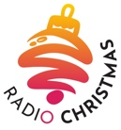
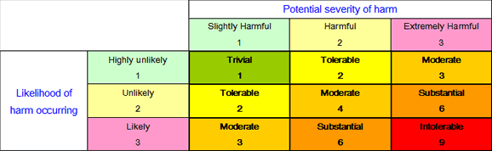
RISK ASSESMENT FORM: RADIO CHRISTMAS STUDIO VISIT

Date of visit:
Teacher Responsible:
Number of Children:
Number of Adults:

HAZARD | Likelihood of  Risk score: [1-3] | Severity of Risk  score: [1-3]: | Overall Risk score:  [ likelihood x severity] | Hazard reduction measures to be undertaken:  [tick when completed] |  
WEATHER:
Cold / Wet / Stormy weather | 1 | 1 | 1 | Ensure all children wear appropriate clothing if cold
EQUIPMENT:
Misuse of Equipment | 1 | 1 | 1 | Studio Manager to brief all children and staff/adults
LOCATION / TERRAIN:
Slips / Trips / Falls | 1 | 1 | 1 | 1st Aid kit & First Aider available
Cables inside the studios | 1 | 1 | 1 | All wires and cables are all covered up and there are no trip hazards. Radio Christmas is set up in order for volunteers and children to participate.  All electrical equipment is PAT tested.
OTHER:
Behaviour. | 1 | 1 | 1 | If behaviour of any child adversely affects the safety or enjoyment of other visitors or staff, or causes damage to equipment, this person may be asked to leave by Radio Christmas personnel. Children will be briefed.
Volunteers at Radio Christmas | 1 | 1 | 1 | At no time will the children be left alone with any adult or child they are unfamiliar with. We are holding Radio Christmas in a coffee shop that is open to members of the public, so children need to be briefed about this.
REMEMBER: Activities scoring 1-6 (Trivial, Tolerable or Moderate) can be completed with surety once hazard reduction measures are in place. Any activity scoring 7-8 (substantial) should not be attempted unless additional hazard reduction measures are identified in order that would reduce the score. Any activity scoring 9 should not be attempted. Radio Christmas is a public radio service so the children’s voices and images (through a web cam) will be in the public domain.

Headteacher signature: ……………………………………… Date: ………………….. Can the proposed activity take place? YES / NO

